Collstrop Sampling 27.01.2016

Site | Vegetation | Latitude, Longitude | pH
L1 | Healthy, large trees | 55.955151,12.355118 | 4.92
L2 | Stressed small trees | 55.955305,12.355163 | 5.23
L3 | Very stressed few small trees | 55.955410,12.355098 | 7.24
L4 | No trees grass | 55.955484,12.355042 | 6.56
L5 | No trees dark brown moss | 55.955557,12.355192 | 6.71
L6 | Stressed area between healthier trees | 55.955675,12.355280 | 4.80
L7 | Healthy birch trees | 55.955798,12.355264 | 5.75
L8 | Small less healthy birch trees | 55.956012,12.355230 | 6.06
C1 | Southwest corner | 55.955209,12.354534 | 5.69
C2 | Southwest corner | 55.955186,12.354697 | 6.89
C3 | Northeast corner | 55.957763,12.355979 | 6.20

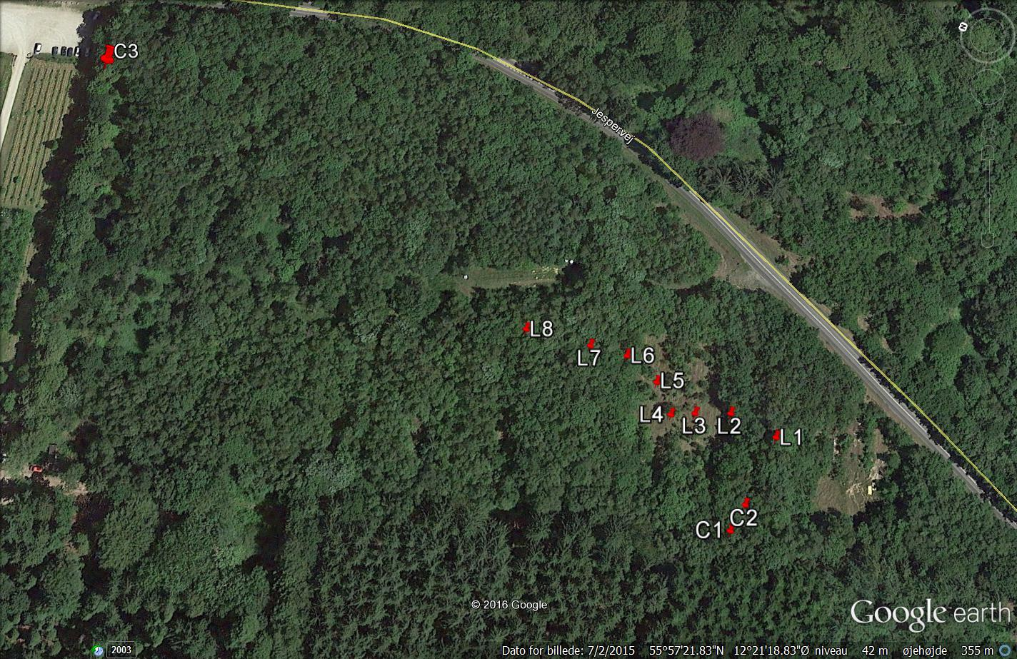
Test containers

